Travis Erwin
CS255 Project Two

CS 255 System Design Document Template

UML Diagrams

UML Use Case Diagram
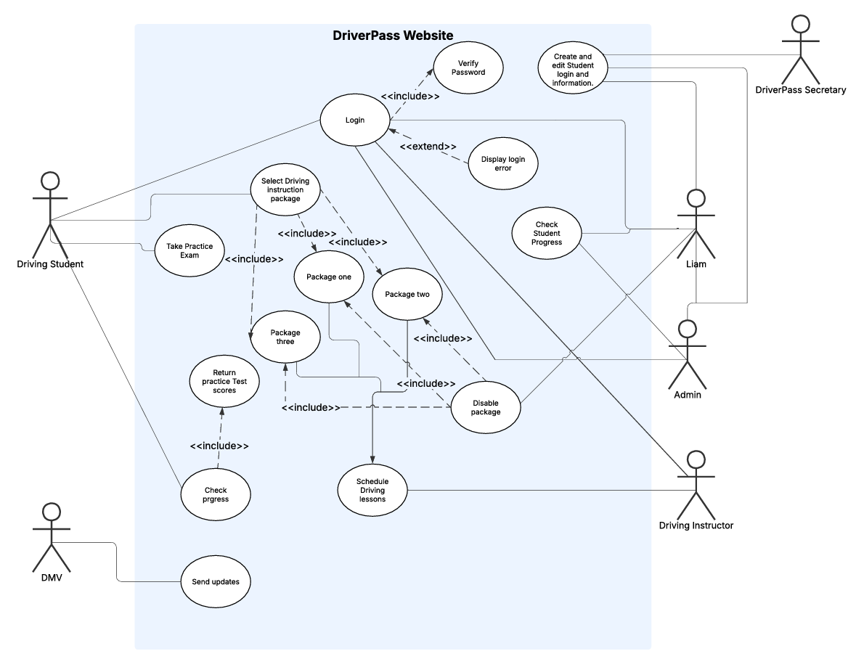

UML Activity Diagrams
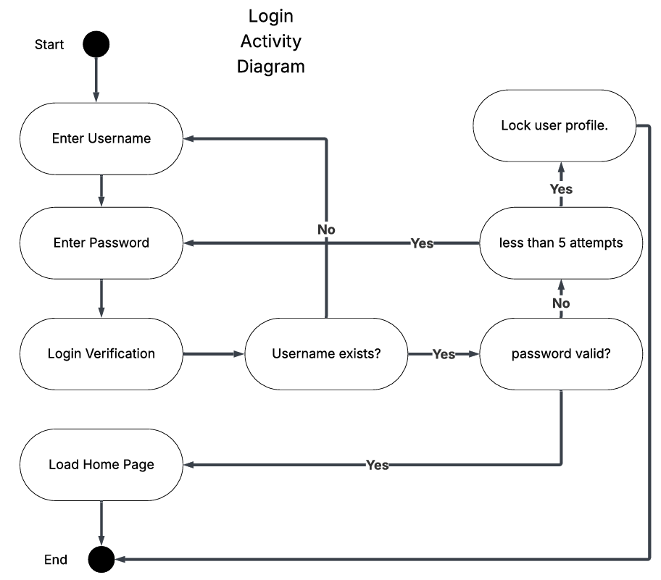
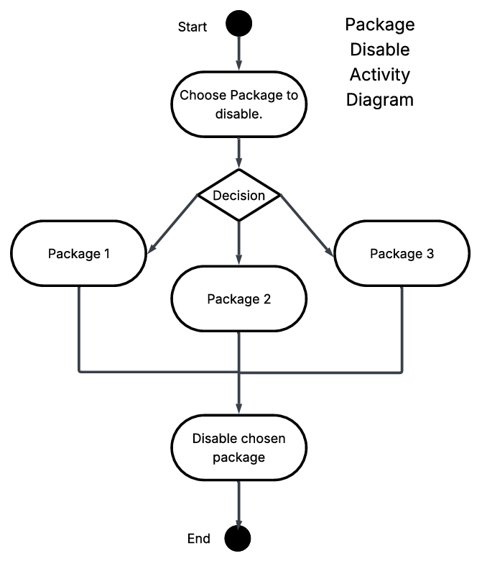

UML Sequence Diagram
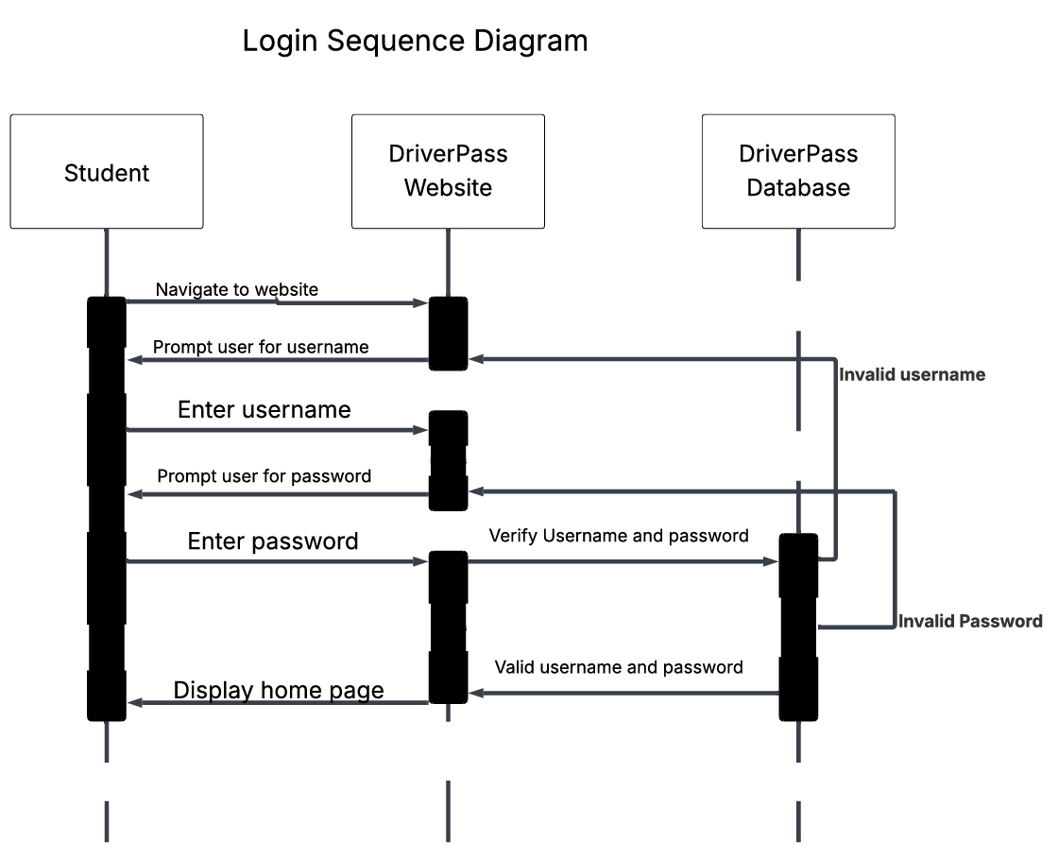

UML Class Diagram

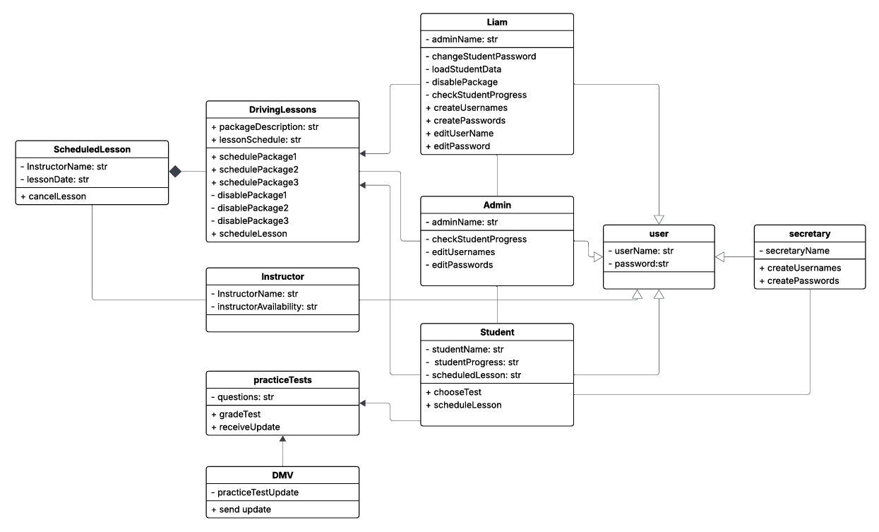

Technical Requirements
System infrastructure requirements:

- The system will run on cloud-based hardware, eliminating the need for an onsite server.
- It will function as a web application accessible through a functional website with users and their respective roles
- The site will allow students to take practice exams and schedule driving lessons, and a database to store all of the data associated with it.
- Admins will be able to edit user data on the front end, eliminating any need for them to code or query a database
Hardware requirements:
- Users will need a device that can access the web whether that is a personal computer or a mobile device.
- There will be no need for onsite server hardware as it the system will be cloud based.

Software requirements:

- A web server, a SQL style database, and a cloud managed OS will be required on the server side.
- A user will need a modern web browser
- Backend cloud based relational database to store user data

Tools requirements:
- Tools needed to complete the project will be an IDE like Visual Studio or Eclipse and testing tools to ensure security and functionality of the system.
- A computer to access the Cloud Server will be necessary to setup the system.

Security requirements:
- Passwords will be encrypted
- If a user fails to enter the correct password in 5 attempts then they will be locked out of the system, requiring an administrator to reset the lockout for the user.
- Role based measures will be implemented to ensure that only certain users can access specific information and functions.
- All data passed between clients and the server will use HTTPS encryption

